23AI2003 –Artificial Intelligence for Web Development Lab
URK23CS5003

Ex. No: 06 | Working with Jquery

1. Interactive Event Details Display using jQuery

Aim

To develop an interactive event display webpage using jQuery that dynamically shows event details, applies effects, and passes selected event data to a registration form.

Description

The application allows users to view multiple events displayed on a webpage, where each event contains a title, date, and hidden additional details. When the user clicks the “Show Details” button, the hidden content is displayed using jQuery effects, and the button text toggles between “Show Details” and “Hide Details”. The selected event is highlighted by changing its background color, and the corresponding event title is accessed using traversing methods and displayed in an alert box. The user can click the “Register” button to navigate to a registration form page, where the selected event name is automatically passed and displayed in a non-editable text field. This experiment demonstrates the use of jQuery selectors, DOM manipulation, event handling, effects like slideToggle(), traversing methods, CSS manipulation, and data transfer between webpages.

Code
<!DOCTYPE html>
<html>
<head>
<title>Event Details</title>
<script src="https://code.jquery.com/jquery-3.6.0.min.js"></script>
<style>
.event { border:1px solid black; padding:10px; margin:10px; }
.details { display:none; }
</style>
</head>

<body>

<div class="event">
<h3>Tech Fest</h3>
<p>Date: April 10</p>
<div class="details">
<p>Technical events and coding contests</p>
<button class="register">Register</button>
</div>
<button class="toggle">Show Details</button>
</div>

<div class="event">
<h3>Music Night</h3>
<p>Date: April 12</p>
<div class="details">
<p>Live music performances</p>
<button class="register">Register</button>
</div>
<button class="toggle">Show Details</button>
</div>

<script>
$(".toggle").click(function() {
let eventDiv = $(this).parent();

eventDiv.find(".details").slideToggle();

let btn = $(this);
btn.text(btn.text() === "Show Details" ? "Hide Details" : "Show Details");

$(".event").css("background", "white");
eventDiv.css("background", "lightblue");

let title = eventDiv.find("h3").text();
eventDiv.find("h3").css("color", "red");

alert("Event: " + title);
});

$(".register").click(function() {
let title = $(this).closest(".event").find("h3").text();
window.location.href = "form.html?event=" + encodeURIComponent(title);
});
</script>

</body>
</html>

2. Interactive Event Registration Form using jQuery

Aim
To design and validate an event registration form using jQuery, ensuring proper input validation and dynamic user feedback.

Description
The application provides an event registration form where users can enter their details such as name, email, selected event name, and mobile number. The event name is automatically populated from the previous page and displayed in a non-editable field. When the user submits the form, jQuery is used to retrieve and validate all inputs. If any field is empty or invalid, appropriate error messages are displayed in red and the corresponding fields are highlighted. Email format and mobile number constraints are validated using conditions. If all inputs are valid, a success message is displayed in green, and the submit button is disabled and updated to “Registered”. The reset button clears all inputs and messages. This experiment demonstrates jQuery selectors, form validation, DOM manipulation, CSS styling, event handling, and attribute manipulation.

Code
<!DOCTYPE html>
<html>
<head>
<title>Registration Form</title>
<script src="https://code.jquery.com/jquery-3.6.0.min.js"></script>
</head>
<body>

<h2>Event Registration</h2>

<form id="regForm">
Name: <input type="text" id="name"><br><br>
Email: <input type="text" id="email"><br><br>
Event: <input type="text" id="event" readonly><br><br>
Mobile: <input type="text" id="mobile"><br><br>

<button type="button" id="submit">Submit</button>
<button type="button" id="reset">Reset</button>
</form>

<p id="msg"></p>

<script>
// Get event name from URL
let params = new URLSearchParams(window.location.search);
$("#event").val(params.get("event"));

$("#submit").click(function() {
let name = $("#name").val();
let email = $("#email").val();
let mobile = $("#mobile").val();

let valid = true;
$("#msg").text("");

if(name === "" || email === "" || mobile === "") {
$("#msg").text("All fields required").css("color","red");
valid = false;
}

let emailPattern = /^[^ ]+@[^ ]+\.[a-z]{2,3}$/;
if(!email.match(emailPattern)) {
$("#msg").text("Invalid Email").css("color","red");
$("#email").css("border","2px solid red");
valid = false;
}

if(!/^\d{10,}$/.test(mobile)) {
$("#msg").text("Invalid Mobile").css("color","red");
$("#mobile").css("border","2px solid red");
valid = false;
}

if(valid) {
$("#msg").text("Registration Successful for " + name)
.css("color","green");

$("#submit").prop("disabled", true).text("Registered");
}
});

$("#reset").click(function() {
$("#regForm")[0].reset();
$("#msg").text("");
$("input").css("border","");
});
</script>

</body>
</html>

Input & Output
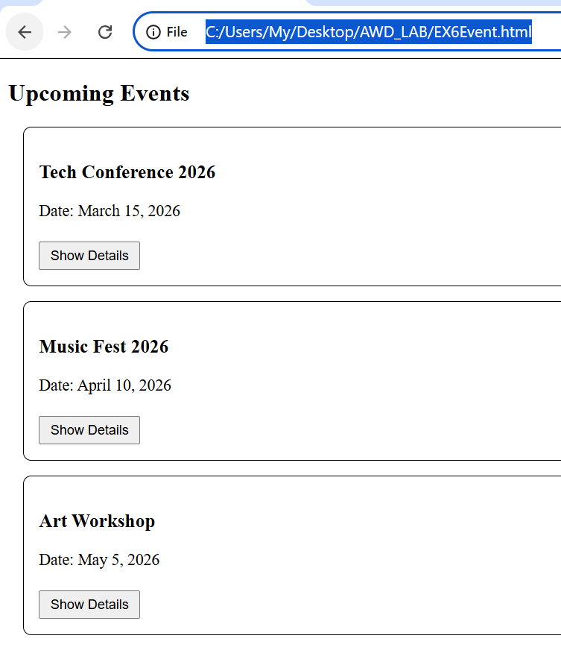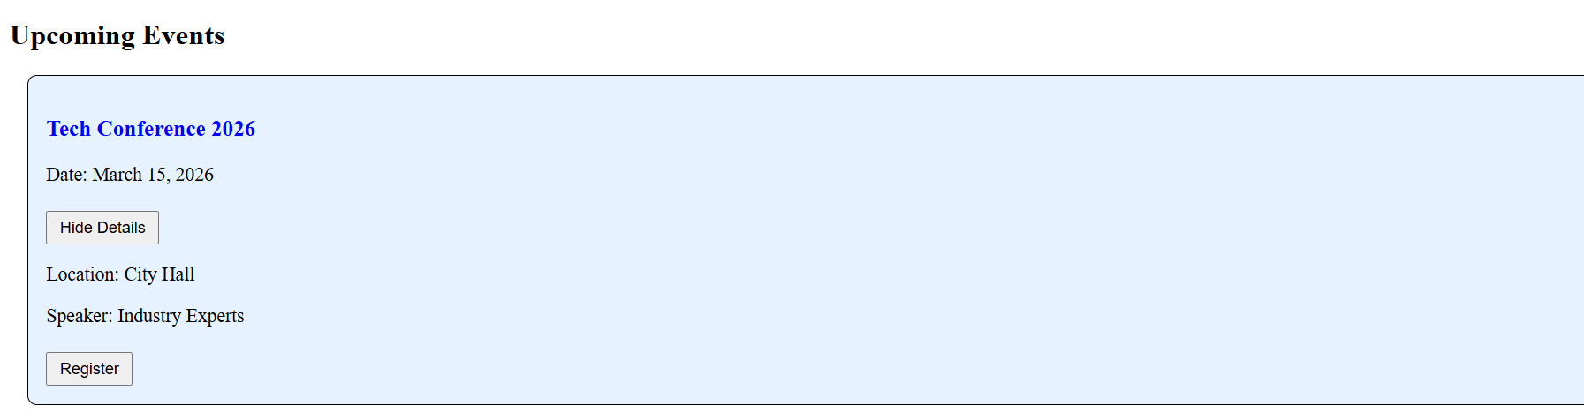
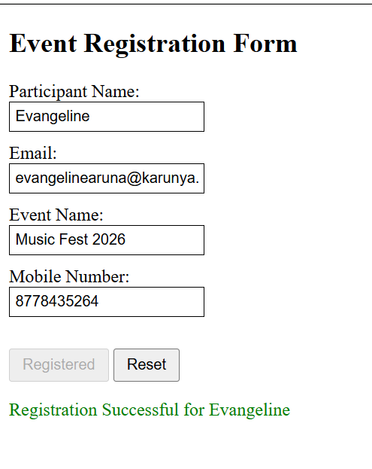

Result
The experiment is successfully completed.

